Scientists find key to 'turbo-charging' immune system to kill all cancers

By Sarah Knapton, Science Editor 7:00PM BST 16 Apr 2015

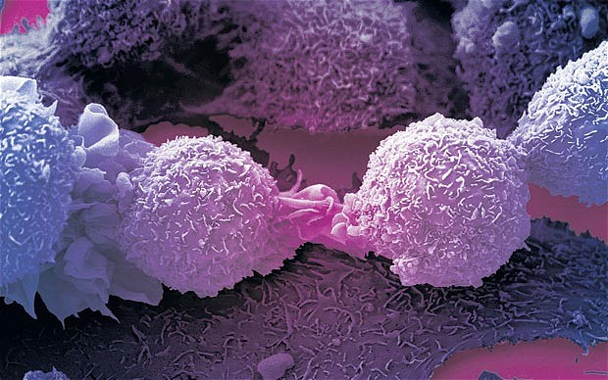

A protein which ramps up the immune system has been discovered by scientists at Imperial College London

A protein which ‘turbo-charges’ the immune system so that it can fight off any cancer or virus has been discovered by scientists.
In a breakthrough described as a ‘game-changer’ for cancer treatment, researchers at Imperial College found a previously unknown molecule which boosts the body’s ability to fight off chronic illnesses.
Scientists at Imperial College London, who led the study, are now developing a gene therapy based on the protein and hope to begin human trials in three years.
“This is exciting because we have found a completely different way to use the immune system to fight cancer,” said Professor Philip Ashton-Rickardt, from the Section of Immunobiology in the Department of Medicine at Imperial, who led the study.
“It could be a game-changer for treating a number of different cancers and viruses.
“This is a completely unknown protein. Nobody had ever seen it before or was even aware that it existed. It looks and acts like no other protein.”
The protein – named lymphocyte expansion molecule, or LEM, promotes the spread of cancer killing ‘T cells’ by generating large amounts of energy.
Normally when the immune system detects cancer it goes into overdrive trying to fight the disease, flooding the body with T cells. But it quickly runs out of steam.
However the new protein causes a massive energy boost which makes T cells in such great numbers that the cancer cannot fight them off.
It also causes a boost of immune memory cells which are able to recognise tumours and viruses they have encountered previously so there is less chance that they will return.
The team made the discovery while screening mice with genetic mutations. They found one type produced ten times the number of cancer-fighting T cells, suppressing infections and becoming resistant to cancer.
Researchers found that the mice with enhanced immunity produced high levels of the unknown protein which is also found in humans.
They are hoping to produce a gene therapy whereby T cells of cancer patients could be enhanced with the protein and then injected back into the body. It could end the need for harsh chemotherapies as the body itself would be fighting the disease, rather than toxic drugs.
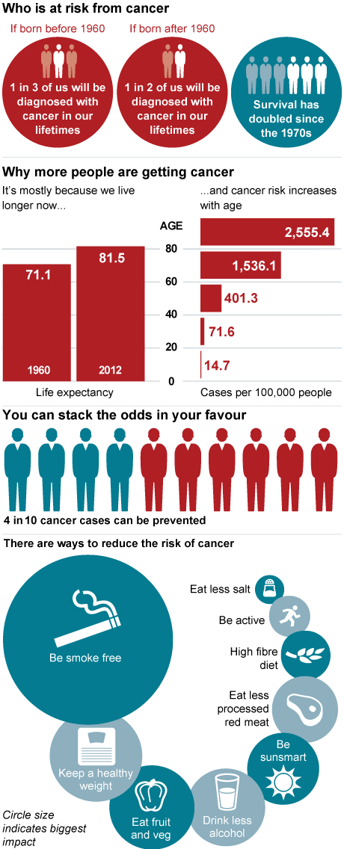
Dr Mike Turner, Head of Infection and Immunobiology at The Wellcome Trust, said: “The discovery of a protein that could boost the immune response to not only cancer, but also to viruses, is a fascinating one.
“Further investigation in animal models is needed before human trials can commence, but there is potential for a new type of treatment that capitalises on the immune system’s innate ability to detect and kill abnormal cells.”
Charities said the protein showed 'great promise' and were eager to see if it could be translated into humans.
Dr Alan Worsley, senior science information officer at Cancer Research UK, said: “This exciting work in mice is still at an early stage and only looked at one type of cancer.
“Cancer often finds a way to suppress the immune system, but drugs that overcome this and allow immune cells to target cancer show great promise. Research into the biology of the immune system could help develop more effective treatments by increasing the number of cancer-killing immune cells.
“The researchers now need to figure out how to develop drugs that target this molecule, and whether doing so would be safe and effective in cancer patients.”

